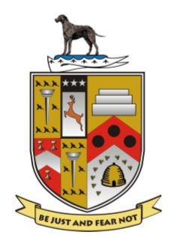
Lurgan Rugby Football & Cricket Club

Health & Safety Policy
1.0 Policy Statement
Lurgan Rugby Football and Cricket Club is strongly committed to encouraging our members to take part in rugby football and cricket in a healthy and safe environment.
Under the Health & Safety at Work (NI) Order 1978 and other related statutes, Lurgan Rugby Football and Cricket Club (LRFCC) have duties to our members, employees, contractors, visitors and the general public.
Our duties include ensuring that the maintenance and operation of the property we occupy, and any plant and equipment installed or used at the premises and grounds is managed safely. We also have duties in respect of provision of safe systems of work, employee training and employee welfare.
LRFCC has a legal and a moral obligation to safeguard anyone who may be affected by our undertaking. We fully accept our obligations and responsibilities and ensure, so far as is reasonably practicable, the health, safety and welfare of our members, employees, visitors and anyone else who may be affected by the actions of the club.

Members and employees are required to co-operate with the Club, not only to ensure their own personal safety but also to ensure that they are not in breach of legislation.
The members and employee’s specific responsibilities are: -
- To comply with all health and safety rules and safe systems of work instigated by the Club.

- To take reasonable care for the health and safety of themselves and of other persons who may be affected by their acts or omissions.

- Not to intentionally or recklessly interfere with or misuse anything provided in the interests of health, safety or welfare.

Guidance as to how this policy is to be implemented can be found in Parts 2 – 3 of this policy document. The details of this safety policy are to be made available to all members and employees and are to be reviewed annually and updated as required.

