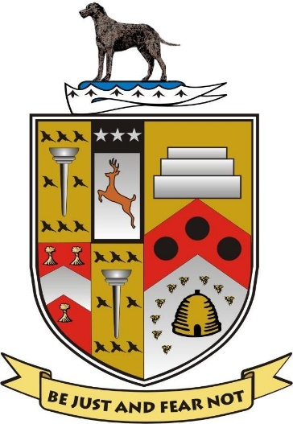
Lurgan Rugby Football Club
Designated Person for Safe Guarding

Mr. Jordan Jones (Child Welfare Officer)
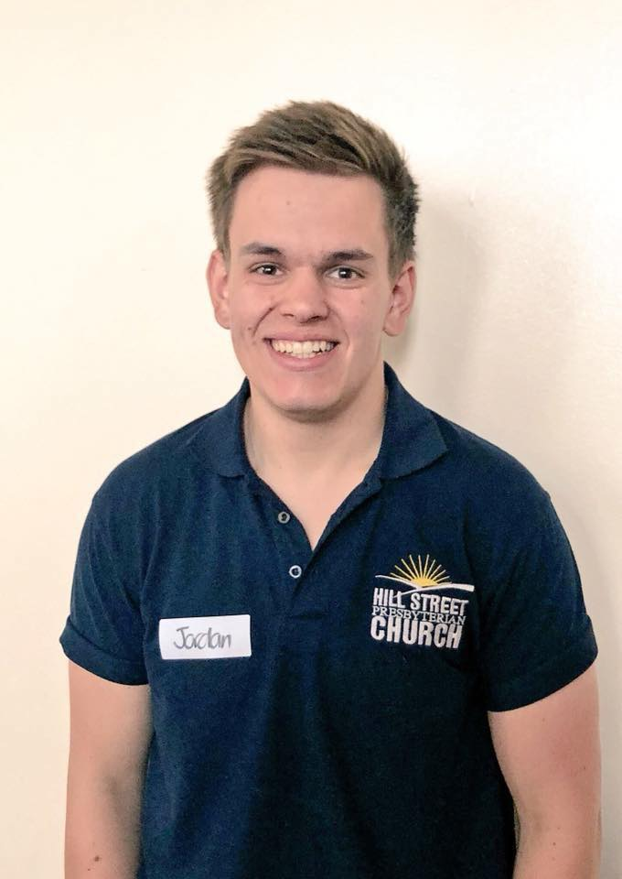

Contact Details

Mob:
07787 339249
Email:
jordanrjones@btinternet.com
Web:
www.lurganrugbyclub.com

