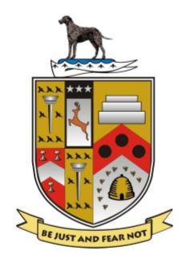
Lurgan Rugby Football & Cricket Club

Equal Opportunities / Sports Equity Policy
Lurgan Rugby Football & Cricket Club (the Club) recognises the importance of affording equity, equal opportunity and fair treatment to all present and potential employees and members.

The Club aims to ensure that all people, irrespective of their age, gender, ability, race, religion, ethnic origin, creed, colour, nationality, social status or sexual orientation, have a genuine and equal opportunity to participate in rugby union at all levels and in all roles. That includes participation as a beginner or elite performer, and as a coach, official, referee, manager, administrator or spectator.

In its relationships with members, employees, and in its provision of services, It is the aim of the Club not to disadvantage any individual by imposing any conditions or requirements which cannot be justified. Failure to comply may result in disciplinary action being taken.

Advice and training will be given to all those working for or on behalf of the Unions. Direct discrimination is defined as treating a person less favourably than others or would be treated in the same or similar circumstances.

Indirect discrimination occurs when a requirement or condition is applied which, whether intentional or not, adversely affects a considerably larger proportion of people of one race, sex or marital status than another and cannot be justified on grounds other than race, sex or marital status.

Exemptions

Lurgan Rugby Football & Cricket Club reserves the right to limit competitions to persons of specific age, gender or disability groups where this is necessary to ensure equitable, safe and equal competition.

Responsibility

Lurgan Rugby Football & Cricket Club expects all those acting on behalf of the organisation to adhere to this policy.

In pursuance of this policy the Club reserves the right to discipline any of its members or employees who practice any form of discrimination on the grounds of a person’s age, gender, ability, race, religion, ethnic origin, creed, colour, nationality, social status or sexual orientation.

