Lurgan Rugby Football & Cricket Club
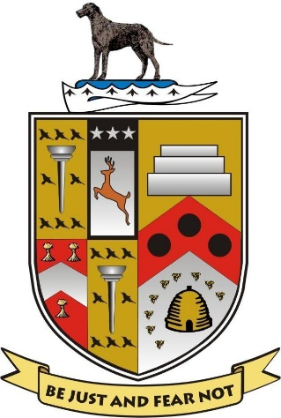
Management Committee (2017 – 2018)
Patron Mr. Jackie Leatham
President Mr. Chris Stevenson
Vice President Mr. Paul Wilson
Chairman Mr. Billy Boyd
Honorary Secretary Mr. Albert Dunlop
Honorary Treasurer Mrs Nichola Richardson
PRO & Head of Events Mr. Raymond Acheson
Grounds Convenor Mr. Kyle Geddis
Bar Convenor Mr. Stephen Black
Data Officer Mr. Dale Richardson
Head of Finance Committee Mr. Sam Rusk M.B.E
Cricket Section Mr. Gary McCullough
Rugby Section (Chairman) Mr. Mark Prentice
Cricket Section Mr. Ross McCollom
Rugby Section Mr. Aaron Carson
Cricket Section (First Team Captain) Mr. Richard Clarke
Rugby Section Mr. Lee Derby

